|  |
| --- |
| Back alley gang |
| Phat Beats |
| Design Document |
|  |
| **Compiled By:**  Jeremy Desha  Jeffery Sventora  Joe Ricks  Ralph Conception |
| **2/4/2012** |

|  |
| --- |
| This document will contain all of the information regarding the design elements/aspects of the game “Phat Beats” |

Contents

**Executive Summary** 4

High Concept 4

Genre: 4

Platform: 4

Minimum System Requirements 4

Target Audience 4

Key Features 4

User Experience 4

Goal 4

**Interactivity** 5

Game Modes 5

Controls 6

Menus 6

Game State 6

Cameras 7

Interface 7

Main Game Menu 7

Options 7

Save Slots 7

Credits 7

New Game 7

Load Game 7

Arcade 7

Character Selections 7

Quit 7

Pause Menu 9

Heads up Display (HUD) 9

**Art & Production Design** 10

Style of Art & Animation 10

Style of Audio Effects 10

Style of Music 10

Dust Jacket 11

Expanded Description 11

**Characters** 12

Playable Characters 13

Luke Skywalker 13

Darth Vader 14

Yoda 15

Darth Maul 16

**Levels** 17

Death Star 17

Hoth 18

**Game Play** 19

Game Specifics 19

Example of Game Pacing 20

Game Events 20

Game Progression Milestones 20

**Game Screens Layout** 21

In Game HUD 21

Main Menu 22

Arcade 22

Load Screen 23

Save Screen 23

Options Menu 24

Credits Screen 24

Pause Screen 25

Game Play Screen 25

**Influences & References** 27

World Visual Influences 27

Rhythm Spirit 27

GuitaruMan 27

Character Influences 28

Star Wars 28

**Executive Summary**

## High Concept

Hit consecutive musical notes to the song’s beat to defeat your opponents.

## Genre:

Rhythm Versus

## Platform:

Windows XP/Vista/7 x86 or x64

## Minimum System Requirements

* Processor: 1.4Ghz Dual Core
* Memory: 512 Mb RAM
* Graphics: DirectX 9.0 Compatible Graphics Card with at least 128Mb VRAM

## Target Audience

This game targets fans of rhythm games and/or Star Wars. In addition, this game will target anyone that is at least 13 years of age and interested in a unique style of fighting game.

## Key Features

* Rhythm powered fighting sequences
* Engaging music draws in players
* Amazing fight sequence visuals keep player in the action

## User Experience

* Head to head rhythm “fighting” where players try to best each other or the AI for points and story progression.
* Re-playable fight scenes for song enjoyment and challenge.

## Goal

* Press all the correct key combinations
* Defeat your opponents.

**Interactivity**

## Game Modes

* Press all the correct key combinations
* Defeat your opponents.

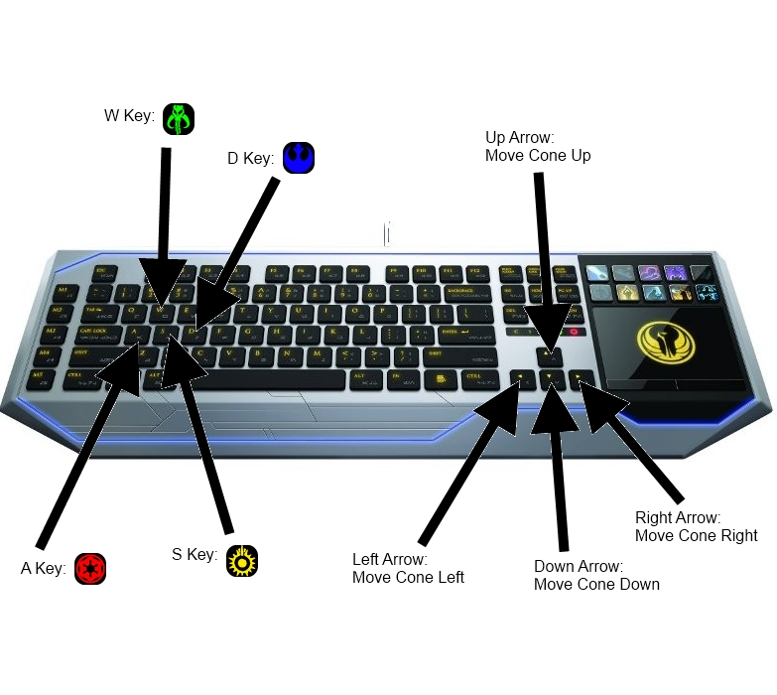

## Controls

### Menus

Move through the menu using the arrow keys to go up and down. Choose/confirm selection with the Enter key.

### Game State

The user will have to press one or more of the same keys at a specific time to get the points and attack the other player. You will need to press one of the arrow keys to move the cone in the correct direction of the note. You will also have to press one of the symbols that appear using the W, A, S, or D key. You will need to press in the direction the note is coming from and press the symbol that is on screen. The symbols will be of the Rebel Alliance (blue), the Galactic Empire (red), the Mandalorians (green), and Black Sun (yellow).

https://lh6.googleusercontent.com/IrEqTJyredZcKuGAgqWv7_2FU36mQs05OZuOwnRk1kNngFjyPTiaklBrqv-2Sua4kle75ENzW9PqA1MWGsg2a8qLDZ7NIYMbqqGvBNrVikRvbxrXsn0https://lh4.googleusercontent.com/uz_LlhDGsGeqZ_4YqDKL1QKUTL4yBrnWyn_tjdDhpL72PN_19z9Adj8pELOeJFLB-EfaQ8_8RKP5R21MR7siOZxpZBcjGvCUWPbg57CEBmgBi0a0NGshttps://lh6.googleusercontent.com/W3Q7QJMKZxuG5y61gYKWKpUAO1yfxuJwLsfl_6Zpd6RB02-mHDbAag18JCLoR0aFt61NO3bDr0dAzNB5lPSgsc7iIkn-hRxdYSrzejFRyndzaQX7H5ohttps://lh5.googleusercontent.com/63IBE-DaOpIy2rnI8V09ny4PHYvzDQ9agpx0tpEcu2LaUgQc348A-KYJnyIo9u3o4DX-68ctfdXFk_3hZJJ9Hg1VyWPJgrkD_Rt7s76yA4OnlMjvyH4

## Cameras

One static camera focused on the player. Parallax scrolled environments will appear below the players. The camera will never move.

## Interface

### Main Game Menu

All menus will slide in from the right when selected and out to the left when exited. These transitions will take 0.5 seconds. The main color will be black with yellow secondary highlights and accents. Tertiary accents will be characterized by bright red and blue. The font will be composed of the Star Wars font used in the scrolling intros to the movies. The font will also appear in yellow.

### Options

* Music Volume
* Sound Volume
* Difficulty
* Selected option indicated with a rebel/empire icon on each side

### Save Slots

* Slot 1 – 3
* Active slot

### Credits

* All of us
* Scrolling from bottom to top then cuts out to main menu at end

### New Game

* Starts new game in active save slot
* Fades to game play state and load first level in story mode

### Load Game

Fades to game play state and load first level in story mode

### Arcade

* Displays list of songs / fight scenes and allows selection
* Upon selection of a song, takes player to character selection

### Character Selections

* Displays list of available characters to play with
* Upon selection takes player to song and “fight” scene

### Quit

Quits the game

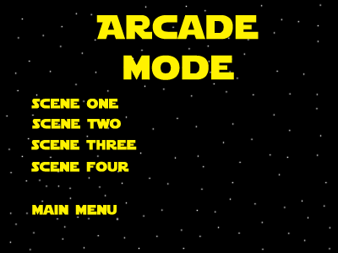 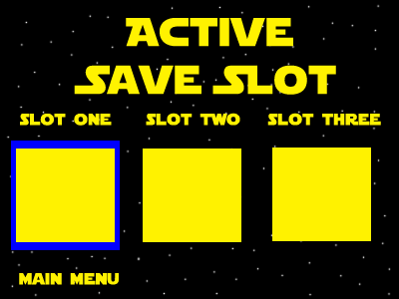 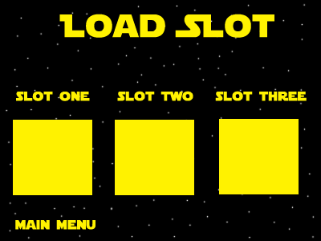

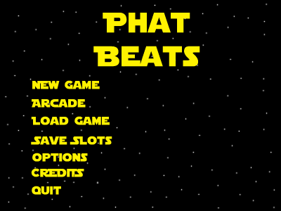 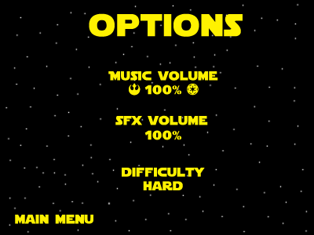 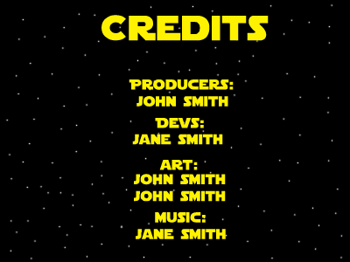

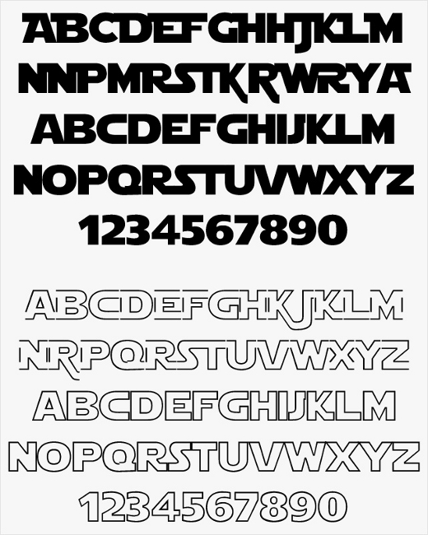

### Pause Menu

**Resume:**

Takes player back to the game they were playing

**Options:**

Takes player to the options screen from main menu

**Quit:**

* Takes player back to main menu, exiting their current game
* Will give a warning before allowing player to exit

### Heads up Display (HUD)

The play screen while active will have four bars, overlaying the characters representing the AI or players. Two bars will be player health, decreasing each other on consecutive combo hits. The last two bars will be power bars that increase when a player hits consecutive notes. Player one’s health bar will be top left of the screen, at the 90% limit. Their power bar’s top limit will run just below their health bar and down the left side of the screen. Player two’s health bar will be bottom right of the screen within the 90% limit. Their power bar’s bottom limit will be just above their health bar’s top top and run up the right side of the screen. An target dot will be displayed 200 pixels towards the center of the screen on each player’s side. A cone will be displayed with it’s point on the target dot when the player or AI is “aiming” towards the incoming note. Similar to Guitaroo Man. Notes will stream towards this target dot, and the player needs to be aiming at it and hit the corresponding button. The color scheme will be red for health bars, transparent grey at 30% alpha for the combo cone, and power bars will be light blue, and glow upon charge up.

(see layouts section for mockup of in game HUD)

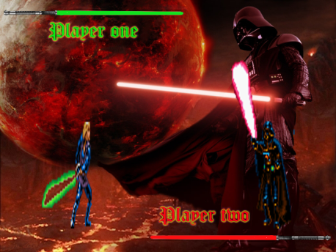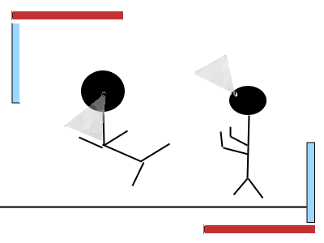

**Art & Production Design**

## Style of Art & Animation

The style of art will have a sleek & modern feel. The shading and detail should not be too involved however the basic outlines should be noticeable. The most appropriate comparisons would be DDR (Dance Dance Revolution) or Star Wars: Clone Wars.

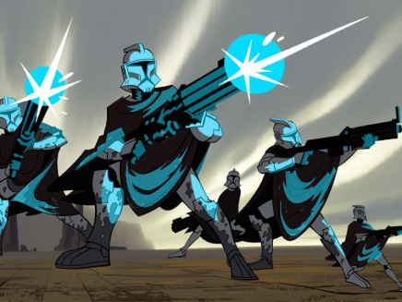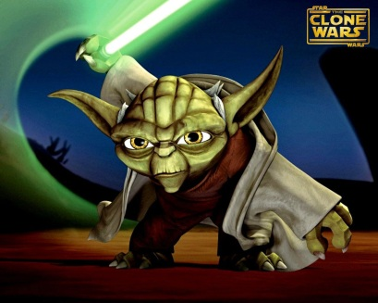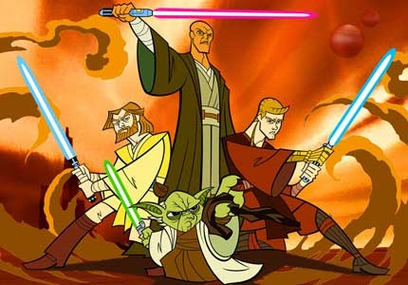

## Style of Audio Effects

The style of audio effects should mimic that of a cartoon, quick and snappy with a bit of flare. Most of the sound effects will revolve around the clash of the characters and their lightsabers. File type will be “.xwm” and will be using XAudio2 for sound effects and music files.

## Style of Music

Electronic, upbeat and grimy dubstep is the key. The music should keep the player anxious and aware while providing soothing sounds to the soul.

**Treatment**

## Dust Jacket

Electronic, upbeat and grimy dubstep is the key. The music should keep the player anxious and aware while providing soothing sounds to the soul.

## Expanded Description

Welcome to the classic battle of Luke Skywalker vs. Darth Vader. This time though, the player will control what happens between the two through a rhythmic series of key combinations. By pressing specific keys to the beat of the music, the player will be able to attack the other player and hopefully defeat him as well. After filling up your power bar, you can hit your opponent with a special move. These special moves can be anything from healing yourself to doing more damage to your opponent.

**Characters**

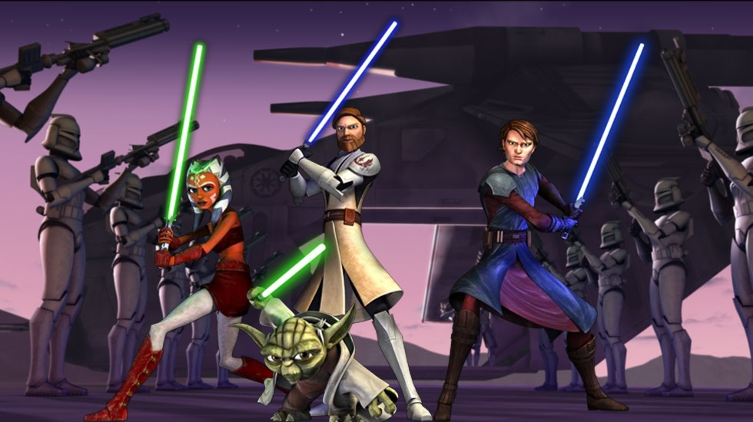

## Playable Characters

### Luke Skywalker

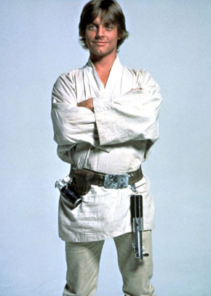

* **One-Sentence Description:** Son of Vader and unwitting Jedi
* **Back-story:** Luke has lived on the planet Tattooine most of his life and is one day thrust into action against the Empire through the death of his “parents”.
* **Visual Design:** Luke Skywalker in the “Clone Wars” style
* **Visual Attributes**
* **Gender:** Male
* **Height:** 5ft 6in
* **Age:** 18
* **Hair color:** Blonde Hair
* **Hair style:** Short Wavy Hair
* **Eye color:** Blue Eyes.
* **Ethnicity:** Human
* **Skin tone:** Light
* **Clothing:** White robe with utility black belt. He will be wearing white cloth wrapped boots.
* **Individual Sprite Size:** 128x256 pixels
* **Game Play Attributes:** When successfully attacking, characterized by quick sharp attacks. Stalwart defenses, but hard hits visually can break his guard.
* **Weapon of choice:** Blue Single Light Saber.
* **Abilities:** Health healing upon activating power bar.
* **Game mechanics:** Standard attack and defense in accordance with the beat system. Player / AI will go into attack or defense mode and their skill at hitting the notes will determine hits, misses, and successful defenses.
* **Design influences:** Luke Skywalker
* **Vocabulary of motion:**
* **Effects necessary for character:** Light saber glow and particles, Healing Glow. Floating/Choking sprite to use if choked by Darth Vader.

### Darth Vader

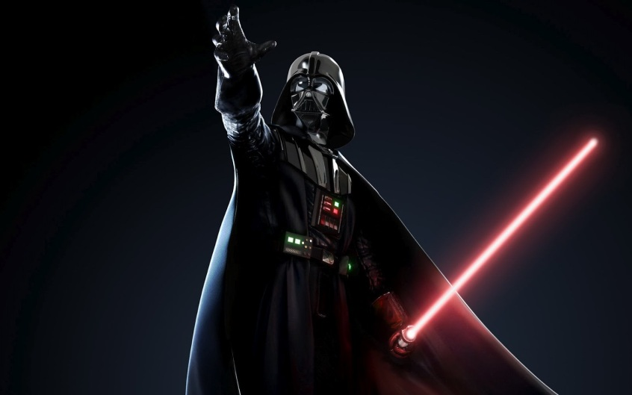

* **One-Sentence Description:** The emperor's right hand and terror of the galaxy.
* **Brief Description:** A hulking evil behemoth with a modulated voice and deep connection with the Dark Side of the force.
* **Back-story:** Luke’s real father from Tattooine, originally a Jedi, but fell to the Dark Side of the force and now operates with the Empire.
* **Visual Design:** Darth Vader also with a “Clone Wars” visual style.
* **Visual Attributes**
* **Gender:** Male
* **Height:** 6ft 7inch
* **Age:** 47
* **Hair color:** None
* **Hair style:** Bald.
* **Eye color:** Brown.
* **Ethnicity:** Human.
* **Skin tone:** Light.
* **Clothing:** Black armored suit with a black helmet. He will be wearing black cape as well.
* **Individual Sprite Size:** 128x256 pixels
* **Game Play Attributes:** Successful attacks are characterized by heavy, slower swings that fueled by hate. Heavy looking defenses that never falter.
* **Weapon of choice:** Red Light Saber.
* **Abilities:** When power bar is activated Vader uses the force to choke his opponent, lifting them from the ground. During this time, he will only take half damage.
* **Game mechanics:**
* **Design influences:** Darth Vader
* **Vocabulary of motion:**
* **Effects necessary for character:** Light-saber glow and particles, red glow on active use of choke.

### Yoda

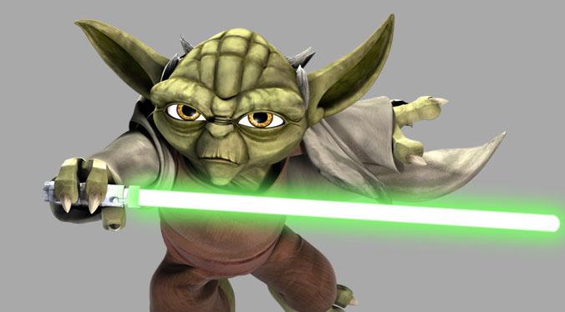

* **Brief Description:** A intelligent being that can control the good side of the force with mind and body.
* **Back-story:** One of the original Jedi's of the order that was part of the rebellion for freedom in the galaxy.
* **Visual Design:** Little green goblin looking with Jedi robes “ Clone Wars “ art style.
* **Visual Attributes**
* **Gender:** Male
* **Height:** 4ft 7inch
* **Age:** unknown
* **Hair color:** None
* **Hair style:** Bald
* **Eye color:** brown
* **Ethnicity:** alien
* **Skin tone:** green
* **Clothing:** Jedi robe brown in color
* **Individual Sprite Size:** 128x256 pixels
* **Game Play Attributes:** Successful attacks are characterized by heavy force push, quick swings that obviously are empowered by understanding.
* **Weapon of choice:** Red Dual Light Saber.
* **Abilities**: 3 consecutive jumps with light saber on the target.
* **Game mechanics:**
* **Design influences:**
* **Vocabulary of motion**:
* **Effects necessary for character:** Light-saber glow and particles. Floating/Choking sprite to use if choked by Darth Vader.

### Darth Maul

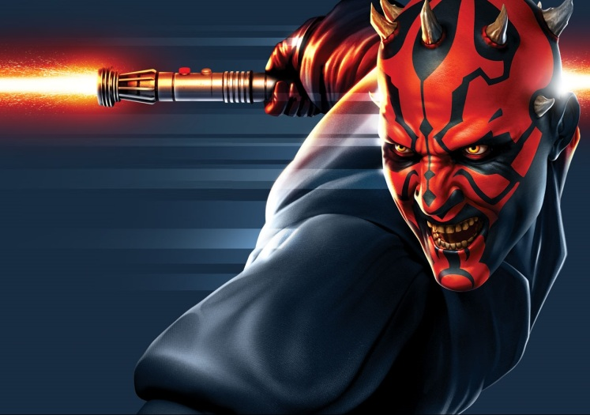

* **One-Sentence Description:** Senator Palpatine’s sith apprentice, and shadow puppet.
* **Brief Description:** An imposing figure with red and black stripes on his face, and short horns protruding from his skull.
* **Back-story:** A mysterious figure recruited by Senator Palpatine before he overthrew the Republic government, and become the Emperor.
* **Visual Design:** Darth Maul also with a “Clone Wars” visual style.
* **Visual Attributes**
* **Gender:** Male
* **Height:** 5ft 7inch
* **Age:** 47
* **Hair color:** None
* **Hair style:** Bald.
* **Eye color:** Yellow.
* **Ethnicity:** Zabrak.
* **Skin tone:** Black and Red.
* **Clothing:** Black robe with hood, black leather gloves.
* **Individual Sprite Size:** 128x256 pixels
* **Game Play Attributes:** Quick precise attacks, characterized by acrobatic moves.
* **Weapon of choice:** Red Double-Bladed Lightsaber.
* **Abilities:** When power bar is activated Maul unleashes an overwhelming flurry of attacks designed to break his opponent’s defenses and inflict pain.
* **Game mechanics:**
* **Design influences:** Darth Maul
* **Vocabulary of motion:**
* **Effects necessary for character:** Light-saber glow and particles. Acrobatic attack sprites, and flurry animation. Floating/Choking sprite to use if choked by Darth Vader.

**Levels**

## Death Star

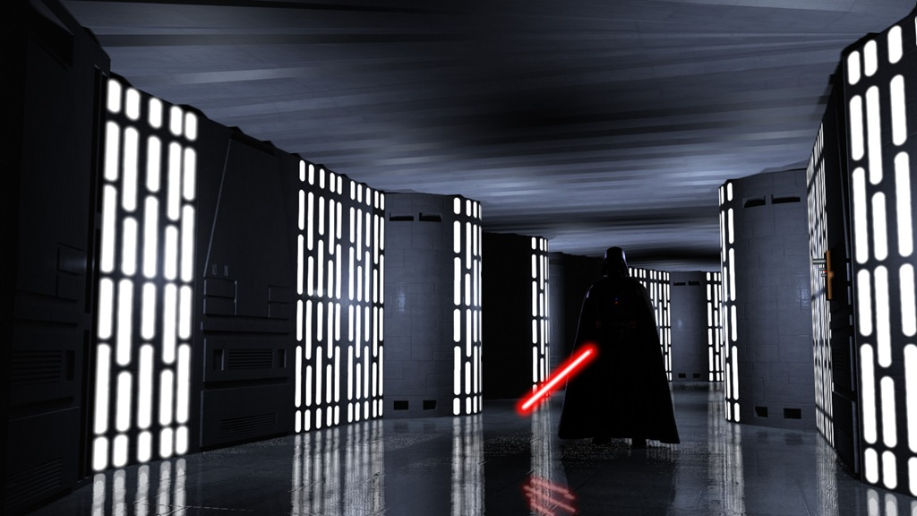

* **Description:** A large open area inside of the Death Star. Everything is made out of quadanium steel. There is a large window in the background where you can see into space. Other planets and stars are visible through this window.
* **Starting Condition:** Both players are next to each other ready to fight.
* **Goal:** Defeat your opponent that you are in battle with.
* **Ambient Environmental Aspects:** Everything has a dark silver color to it. Through the window on the back wall, you will be able to see stars and planets passing by.

## Hoth

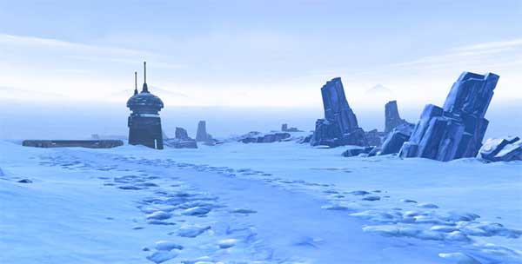

* **Description:** Large open area with snow everywhere. In the background mountains are visible. The ground is covered in snow and the temperature is well below freezing.
* **Starting Condition:** Both players are next to each other ready to fight.
* **Goal:** Defeat your opponent that you are in battle with.
* **Ambient Environment Aspects:** The sky is bright blue. You can’t really see the color of the mountains because the snow is covering them. At times you can see the wind blowing the snow around.

**Game Play**

## Game Specifics

* Each player begins the match with 100 hit points.
* Player’s battle via note combos until one player is dead or match ends.
* Successful “attacks” apply 1 HP of damage to the enemy.
  + Combos add a multiplier to this damage
  + Success in attacks is determined by comparing # of notes hit vs. opponent’s # of notes hit. If higher than defender then attack is successful.
* Players may guard against damage if in guard mode
  + Success in guards is determined by comparing # of notes hit vs. opponent’s # of notes hit. If higher than attacker then defense is successful.
  + Players in guard may automatically perform a counter attack move upon hitting a predetermined note combo.
* Players may switch at will through a button push to be in guard or attack mode
* Matches last 3 rounds
  + A player wins when they win 2 rounds.
  + Rounds last 120 seconds.
  + If a player loses all life they lose the round.
  + If a player doesn’t run out of life, player with most life left wins the round.
* Players will have a power bar for special moves
  + Power bar will fill incrementally upon completing predetermined note combos.
* Players with a full power bar will be able to activate a character specific special move
  + Luke Skywalker will apply 10 points of healing to himself upon activation.
  + Darth Vader will force choke his opponent. This will cause his opponent to take periodic damage which can only be broken by completing notes.
  + Yoda will attack his opponent with 3 flipping attacks which deal incrementally more damage on hit. 1st hit: 2 damage, 2nd hit: 4 damage, 3rd hit: 6 damage.
  + Darth Maul will do a combination of moves that will deal twice as much damage as normal moves. If the opponent is in defense mode, Darth Maul will break that characters block.

## Example of Game Pacing

Examples are given in the amount of time from player beginning a new game till end of game play.

* **0-30 sec:** Player starts new game, enters tutorial. Begins to learn basics of game starting with singular notes. Will build up to combination notes.
* **30sec - 1min:** Player learns how to use directional arrows / joystick to “aim” at incoming notes. Player proceeds into an easy level fight with Yoda.
* **1min - 5min:** Player applies learned skills from tutorial to defeat Yoda and proceed to next stage.
* **5min - 10min:** Player fights Darth Maul in a harder battle, forcing the player to master the key combos, attack and defense, and the power system. If successful they proceed to the next stage.
* **10min - 15min:** Player takes on Darth Vader in an epic final battle. Vader is tough and will require quick reflexes and the player to fully understand how to flow from attack to defense mode. If they are quick enough and keep their wits about them, they may attain victory.
* **15min - 17min:** Credit screen crawl. (Only on story mode.)

## Game Events

### Game Progression Milestones

Mapping button and control inputs for when the beat cone is on if the user hits the combination there will be a particle affect letting them know that it was executed. When fight move was executed the power bar on the side for special moves will increase in size once it reaches the top it will give the user access to a special combo that is specific to character. Rounds will have a random sound track when the new round starts. Rounds will start in a dub step beat and continue in the fight. User will have a start battle notification before the fight starts. When the time runs out, if the other opponent is not down the victor will be judged by how much life is left. Start rendering images and moving the images on the screen from input. Having menu state working and sound implemented. Having the beat and images sync with each other. Having particle and animation rendering with collision detection with both AI, player, and player vs. player. Getting the life bars to change when collision detection is true and the power bar with increase each time a certain amount of moves have been executed.

**Game Screens Layout**

## In Game HUD

* Red – Health
* Grey - Combo cone
* Blue - Power bar
* Notes flow in from 8 directions depending on difficulty Player has to be “aiming” at it and hit the corresponding button when it hits the dot



## Main Menu



## Arcade



## Load Screen



## Save Screen



## Options Menu



## Credits Screen



## Pause Screen

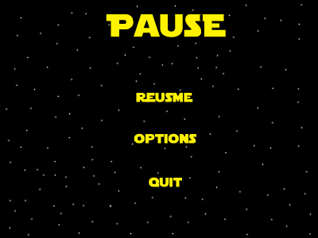

## Game Play Screen

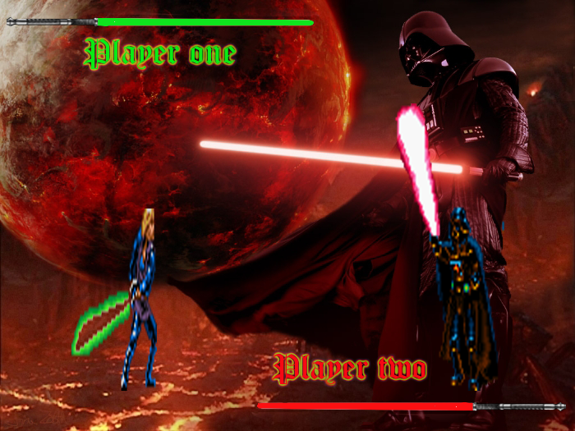

**Influences & References**

## World Visual Influences

### Rhythm Spirit

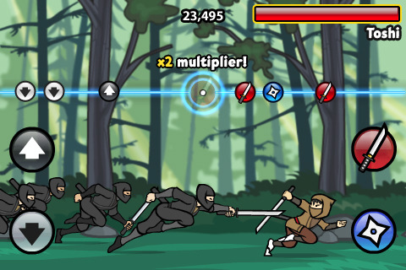

### GuitaruMan

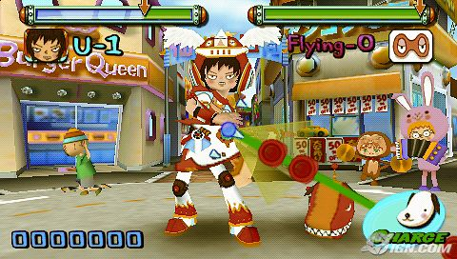

## Character Influences

### Star Wars

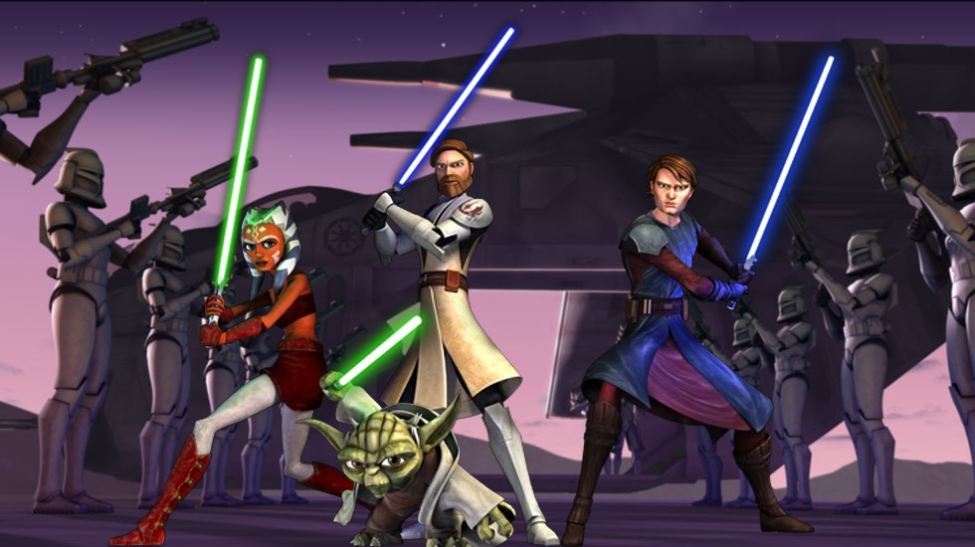

**Technical Documentation**

## AI Flowchart

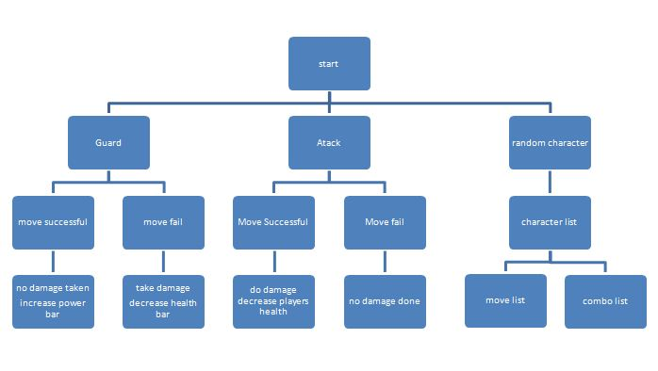

## Interface Flowchart

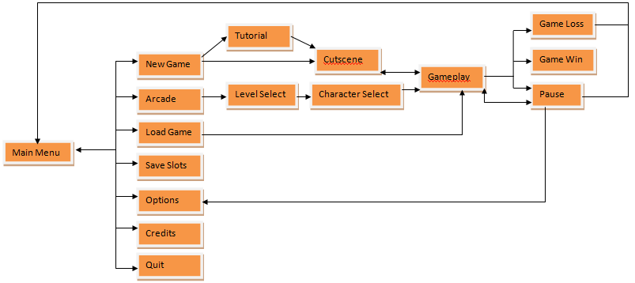

## PRE-EXISTING TECH

### Texture Manager from SGD

Overview: the game will use a texture manager wrapper class that will handle drawing sprites and bitmaps.

### Direct Input SGD

Overview: the game will use a direct input wrapper class that will track our game’s input. It will be modified to work with and with the console.

### Direct X

Overview: the direct x SDK will be used with our particle editor and later used with in our game to render particles.

### XAudio2 Manager from SGD

Overview: The XAudio2 manager wrapper object will load, unload and play our sounds.

### WinMain from SGD

Overview: will contain the WinMain function. set up our window and run the game. This will handle full screen mode toggling. Will also handle the shutting down of the program

**Asset Dependencies  
Characters:  
  
Luke Skywalker:**

* + - **Appearance: His visual appearance will be that of Luke Skywalker from Star Wars Episode IV: A New Hope. The best references of this look would be any pictures of him from the planet Tattooine. He has medium length brown hair that slightly curls out at the end. He has a medium build and is Caucasian complexion. He is wearing a top that goes from his neck to mid thigh. This top is white and seems to made from some sort of rough cloth. He has a belt cinching this top around his waist. The belt is brown with a squared black/blue buckle. His lightsaber usually hangs from his left side on the belt, and his right side has some random cylindrical objects being held in holsters. His pants are a darker beige color, and seem to be made from the same material as his top. They tuck into tan almost-knee-high boots that almost seem to have wrap tops of some sort with black soles. He carries a silver hilted, blue bladed lightsaber.**
    - **Dimensions: A single sprite frame’s canvas space should be 128w by 256h in pixels. Character can take up any sort of space inside of this. White space should be transparent. Comparatively to the other characters Luke should be about medium height.**
    - **Necessary Animations: All animations are side perspective**
      * **Idle stance (ready to attack) - Luke holds his lightsaber with two hands in front of himself, rocking back and forth a bit.**
      * **High Guard (lightsaber swung up high to deflect) - Luke swings his saber up high with the blade diagonal to block an attack**
      * **Low Guard (lightsaber swung low to deflect) - Luke swings his saber down low with blade diagonal to block an attack**
      * **High Attack - Luke swings his saber up high to where an opponent’s head might be**
      * **Low Attack - Luke swings his saber low towards an enemy’s knees**
      * **Mid Attack - Luke swings his saber towards an enemy’s torso**
      * **Choking Animation - Luke is pulled up off the ground about 4 inches (relative to his pixel height) and holds his throat with one hand. His lightsaber is held down near his waist and deactivated. His feet kick back and forth.**

**Darth Vader:**

* + - **Appearance: Vader’s appearance is that of the helmeted version of himself from the original Star Wars trilogy.**
    - **Dimensions: A single sprite frame’s canvas space should be 128w by 256h in pixels. Character can take up any sort of space inside of this. White space should be transparent. Comparatively to the other characters Vader should be the tallest.**
    - **Necessary Animations: All animations are side perspective**
      * **Idle stance (ready to attack) - Vader holds his light-saber with two hands in front of himself, rocking back and forth a bit.**
      * **High Guard (light-saber swung up high to deflect) - Vader swings his saber up high with the blade diagonal to block an attack**
      * **Low Guard (light-saber swung low to deflect) - Vader swings his saber down low with blade diagonal to block an attack**
      * **High Attack - Vader swings his saber up high to where an opponent’s head might be**
      * **Low Attack - Vader swings his saber low towards an enemy’s knees**
      * **Mid Attack - Vader swings his saber towards an enemy’s torso**
      * **Choking Animation - Vader is pulled up off the ground about 4 inches (relative to his pixel height) and holds his throat with one hand. His light-saber is held down near his waist and deactivated. His feet kick back and forth.**

**Yoda:**

* + - **Appearance: Yoda’s appearance is that of himself from the original Star Wars trilogy. He stands ~4ft tall, which translates to being the smallest character in the game. Yoda’s skin is dark green, and because of his age, riddled with wrinkles. He has white fuzzy hair on his head. He only has three thick fingers on his hands. His fingers are tipped by small pointed yellowish/brown claws. His feet similarly are clawed and three toed. He wears a Jedi robe of a rough looking tan material, with a dark brown inner shirt that shows in his upper chest and neck area. He carries a silver hilted, green bladed lightsaber.**
    - **Dimensions: A single sprite frame’s canvas space should be 128w by 256h in pixels. Character can take up any sort of space inside of this. White space should be transparent. Comparatively to the other characters Yoda should be the smallest character.**
    - **Necessary Animations: All animations are side perspective**
      * **Idle stance (ready to attack) - Yoda holds his light-saber with two hands in front of himself, rocking back and forth a bit.**
      * **High Guard (light-saber swung up high to deflect) - Yoda swings his saber up high with the blade diagonal to block an attack**
      * **Low Guard (light-saber swung low to deflect) - Yoda swings his saber down low with blade diagonal to block an attack**
      * **High Attack - Yoda swings his saber up high to where an opponent’s head might be**
      * **Low Attack - Yoda swings his saber low towards an enemy’s knees**
      * **Mid Attack - Yoda swings his saber towards an enemy’s torso**
      * **Choking Animation - Yoda is pulled up off the ground about 4 inches (relative to his pixel height) and holds his throat with one hand. His light-saber is held down near his waist and deactivated. His feet kick back and forth.**

**Darth Maul:**

* + - **Appearance: Darth Maul’s appearance is that of himself from Episode 1 of the Star Wars movies.**
    - **Dimensions: A single sprite frame’s canvas space should be 128w by 256h in pixels. Character can take up any sort of space inside of this. White space should be transparent. Comparatively to the other characters Darth Maul should be about Medium height.**
    - **Necessary Animations: All animations are side perspective**
      * **Idle stance (ready to attack) - Darth Maul holds his light-saber with two hands in front of himself, rocking back and forth a bit.**
      * **High Guard (light-saber swung up high to deflect) - Darth Maul swings his saber up high with the blade diagonal to block an attack**
      * **Low Guard (light-saber swung low to deflect) - Darth Maul swings his saber down low with blade diagonal to block an attack**
      * **High Attack - Darth Maul swings his saber up high to where an opponent’s head might be**
      * **Low Attack - Darth Maul swings his saber low towards an enemy’s knees**
      * **Mid Attack - Darth Maul swings his saber towards an enemy’s torso**
      * **Choking Animation - Darth Maul is pulled up off the ground about 4 inches (relative to his pixel height) and holds his throat with one hand. His light-saber is held down near his waist and deactivated. His feet kick back and forth.**

**Sounds**

**Music:**

* **Dubstep - Star Wars themed Dubstep will be the main type of music through out each level. The player should feel anxious while playing and when the music drops, the player should be caught off guard. It should be music that makes the player want to fight until someone is dead. The music will be used for each level, background music in menus, and credits.**

**Sound Effects:**

* **Light-sabers hitting each other.**
* **A ticking sound to transition between each menu item.**
* **A sound for when the player gets a note right. This sound will be played at 30% of the game volume.**
* **A sound for when the player gets a note wrong.This sound will be played over the current levels music.**

